Name: _______________________ ID: _______________________

**Analytical Chemistry II – Quiz (7th April, 2022)**

1) Define the following terms:

phosphorescence: It is the process in which an excited molecule emits a photon while undergoing a transition from an excited triplet state to a lower state of a different spin multiplicity.

vibrational relaxation: It is the process by which a molecule loses its excess vibrational energy without emitting radiation.

2) Draw scheme of double-beam spectrofluorometer. Label all the components.

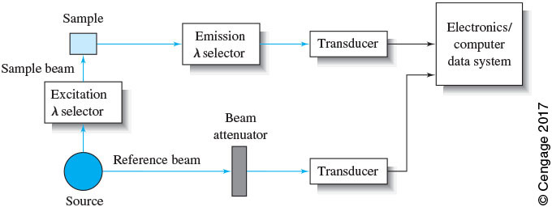

OR

